JS Cheat Sheet

**JS Primitives -> Boolean, number, String , null, undefined**

Boolean= true | false

Number = +-2.2250x10^-308 -> +-1.7976x10^308 | NaN (not a number)(0/0)

String = “<anything delimited by either single/double quotes (but not mix)>”

undefined = no datatype has been assigned

**Creating variable and assigning values ->**

var <variable name> = <directly give value>

Example ->

var a = 10 ;

typeof a //Number

var b = “10”

typeof b //String

var c = true

typeof c //Boolean

**Defining Function**

**function** <functionName> (<comma separated list of arguments>)

{

//your code

return <something> //if return is not given by default function returns undefined

}

To call a function :

<functionName>(<comma separated values you have to give>);

**Example ->**

function abc(a,b,c)

{

var d = a+b+c;

return d;

}

var sum=abc(10,20,30); //sum has 60

**Defining Array**

var <variable name> = [<element1>,<element2>,…… **]**

//you can mix-match type of elements

Accessing/Setting value of array

var myarray=[1,3,”hello”,true**];**

myarray[<index>**]**

**Objects [Reference Types] (Basics)**

**var <variable-name> = { <key>:<value> , … }**

**//here key is the unique attribute/property name and values can be any of the JS dataTypes defined above including other object itself**

**Example:**

**var myObj={ name : ”John”,**

**age: 28 } //curly braces**

**var b = myObj.name // you can access properties through ‘.’ Operator**

**//or**

**var c = myObj[“age”] //c will contain 28 Number**

**Conditional Statements**

**If(//Boolean condition)**

**{**

**}**

**else if(//condition)**

**{**

**}**

**else(//condition)**

**{**

**}**

**Ternary->**

**( expression ) ? <If-true statement> : <if-false statement>**

**Switch ->**

**switch (<variable to check>)**

**{**

**case <value> : <your code>**

**break; //optional if you don’t want your code to fall through**

**default: <default code>**

**}**

**The Document Object->**

“document” object is provided by the browser that provides access to any aspect of webpage. It can be leveraged for DOM manipulation

**Some Common Operations with “document” Object**

**Writing to Web-Page**

**document.write(“hello”);** 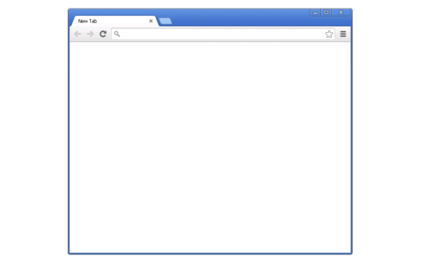

Text gets appended to Web-page

**Variations**

document.write(“<h1>hello</h1>”); //you can add the html code within.

document.writeln(“hello”);//with new line

**Getting an Element in DOM**

**var anchorElement = document.getElementById(“<id assigned to that anchor tag>”);** //gives us the particular anchor element we want to work on.

**Further we can access values,properties,assign functions to inbuilt events (such as onclick , onmouseover etc.)**

***Example***

<button id=”myButton”>Submit</button>

<input type=”text” id=”mytext”>

<script>

var buttonElement=document.getElementById(“myButton”);

var inputElement = document.getElementById(“mytext”);

var getInput = imputElement.value;//will give the value of the user text entered

var a = buttonElement.innerHTML; //variable a will have”Submit”

function abc()

{

alert(“Hello”);// alert is inbuilt function for pop-up

}

buttonElement.onclick=abc; //assign a function to event onclick

</script>